MED D - Follow Me Logic for SilverScript Employer Group Waiver Plans (EGWPs)

General Information
Viewing Claims by UID
Determining if a Claim was Processed Using Follow Me Logic
Related Documents

Description: This document provides information to the MED D Customer Care Representative on Follow Me Logic, which tracks beneficiary history when moving from one account within CVS Caremark’s system to another.

General Information
Follow Me Logic is designed to track beneficiary history when they move from one account within CVS Caremark’s system to another (for example, between the old commercial account and the new Med D account). The history is tracked through the use of Universal IDs. This document can be used to help find information a CCR might need on coverage between the two plans.

Example: This document can be used to determine why a claim was being denied for refill too soon if the prior fill was in the commercial account. Since Accumulations for deductible carry over, a beneficiary may start in commercial and then switch to Med D and get charged the deductible for first fill. Follow Me Logic tracks this type of claim activity and the steps below describe how a CCR can view the claims.

The Universal ID (UID) uses Follow Me Logic (FML) in order to track a beneficiary’s claims from carrier to carrier. The UID is an internal reference number which will not be provided to the beneficiary; therefore, beneficiaries will not be able to provide this number over the phone to help CCRs locate their information.

Note: The UID has no relation to the member ID on the prescription card.

The UID number will be available in many sections of PeopleSafe including Prescription History, Prescription Detail, and Statement of Cost (SOC) screens. Viewing a beneficiary’s profile by searching for UID will display all the beneficiary’s claims that have been processed on RxClaim (regardless of the carrier).

CVS Caremark provides prescription benefits to active workers of an employer client and their retirees through the PBM. When a beneficiary turns 65 and ages into an SSIC EGWP benefit, FML and UIDs will allow continuity across the beneficiary’s active and retiree prescription drug history impacting:

- Claim History
- DUR, refill too soon rejects
- Step Therapy Edits, prerequisite step edits require prior utilization within last 240 days

Notes:
- As a standard practice, Prior Authorizations will NOT carry over. Rare exceptions may be allowed for PAs.
- Accumulations will carry over from a commercial benefit if the client chooses. Any commercial accumulations (deductibles, maximum out of pockets) will apply to Enhanced Wrap Benefit claim calculations only. All standard MED D accumulations (TrOOP and drug spend) will start at $0 for every EGWP beneficiary upon aging into the MedD benefit regardless of the enrollment date or start of the calendar year.
- CCRs must check the plan’s CIF to identify which plans will utilize this feature and to what capacity.

Top of the Document

Viewing Claims by UID
Perform the steps below to view all claims attached to a beneficiary’s UID:

Step | Action
1 | Access a beneficiary’s profile in PeopleSafe.
2 | Click on the Prescription History button on the main page.
3 | Click on the View Claims by UID button at the bottom of the screen.  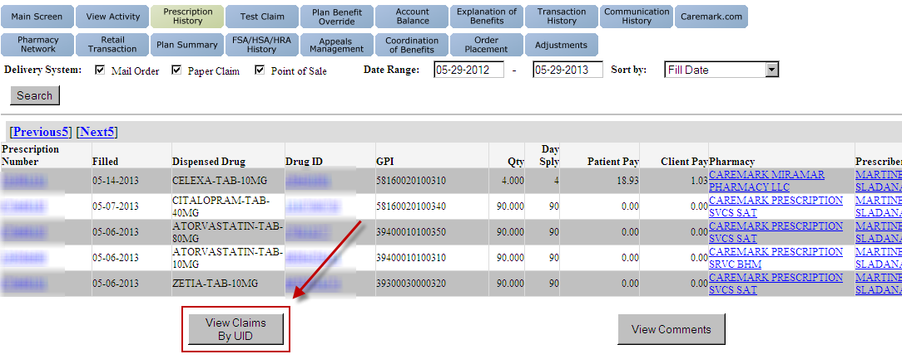  Result: All available claims for the beneficiary will display on the new screen.

Top of the Document

Determining if a Claim was Processed Using Follow Me Logic
The claims that are viewed on the View Claims by UID screen may have been processed while the beneficiary was under another carrier.

Note: See Example within the Overview section for a potential scenario describing why Follow Me Logic is important.

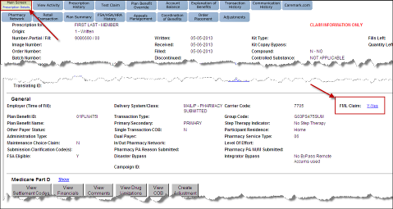

Step | Action
1 | Access a beneficiary’s profile in PeopleSafe.
2 | Click on a Prescription Number from the main screen to access the Prescription Details screen.
3 | Locate the FML Claims field.
3 | If field states… | Then…
3 | Yes | The claim was processed with a UID attached.  Note: This will be a hyperlink which, when clicked, will display a pop-up window with the carrier, account, group, and member ID for the claim. It will also display the UID and any edits.
3 | No/Blank | The claim was processed without this logic.

Top of the Document

Related Documents
Parent SOP: CALL-0048: Medicare Part D Customer Care Call Center Requirements-CVS Caremark Part D Services, L.L.C.
Abbreviations/Definitions: Abbreviations / Definitions

Top of the Document
Not To Be Reproduced Or Disclosed to Others Without Prior Written Approval
ELECTRONIC DATA = OFFICIAL VERSION – PAPER COPY = INFORMATIONAL ONLY

